GRC Fundamentals

Extracted from [here](https://youtube.com/playlist?list=PLarzZ7tJk-lG5qboJ5g3WFfODdswi7uPH&si=oUHlgJQ-aT6R_u-3):

Cybersecurity coins the 2 terms impact and probability

# RISK

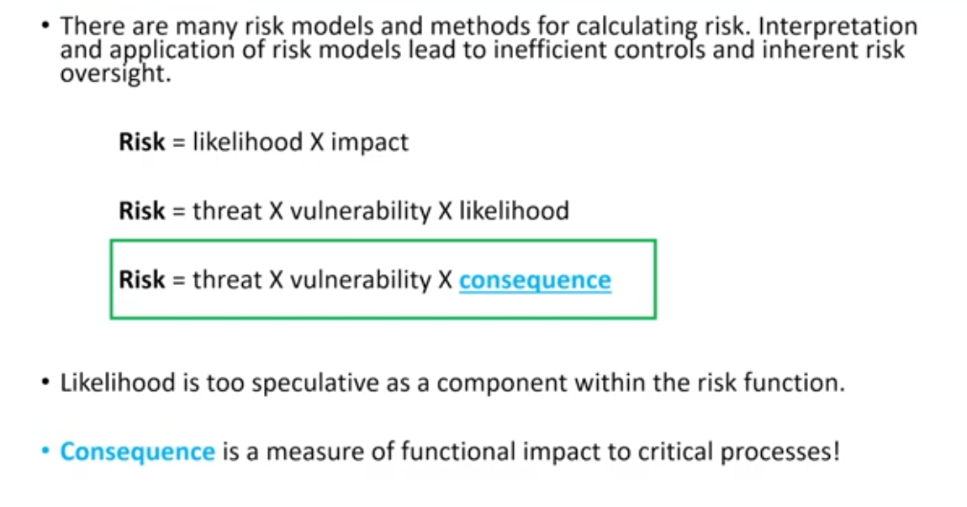

Likelihood a process of best guess effort as to what is the likelihood of this attack. A much better approach consequence results i.e. effects on supply chain, brand, products effected/

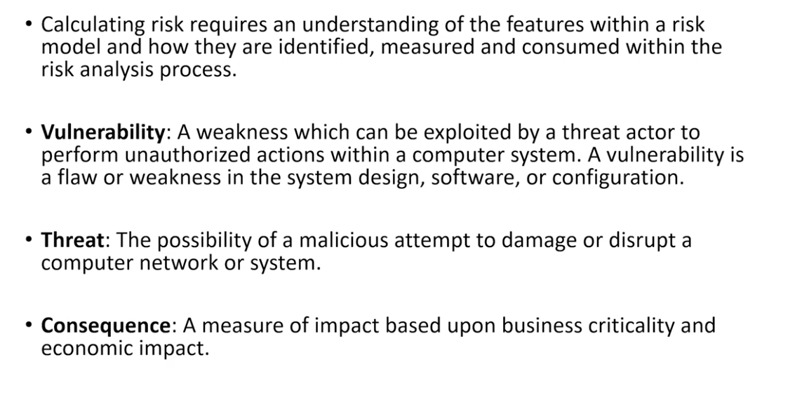

Threat are defined into threat source/actore (who and why are doing), threat vector (social engineering or method or vulnerability they use).

Much better to relate cyber to dollars (this will emphasize more on the **consequence**) rather than zero day or buffer overflow or network traffic analysis or buffer traffic analysis.

* Risk is assessed so that it can be managed. The cost of a security control to manage identified risk should not equal or exceed the relative cost of what is to be protected!
* Risk Avoidance: A business may choose not to conduct an activity to avoid the inherent risk involved.
* Risk Transference: Utilize or transfer the risk to another party for risk management.
* Risk Acceptance: The business accepts the inherent risk and carries on in the business process.
* Risk Mitigation: Security controls are applied to counter the implied risk of the business activity.

## Scenarios

Risk Avoidance

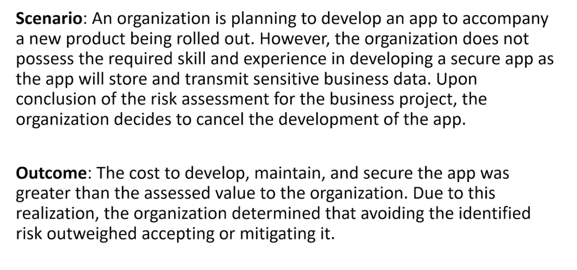

Risk Transference

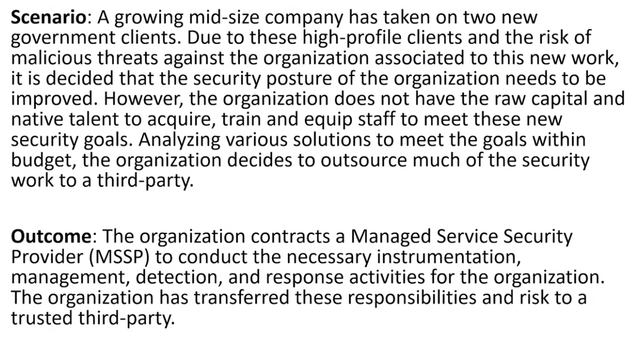

Risk Acceptance

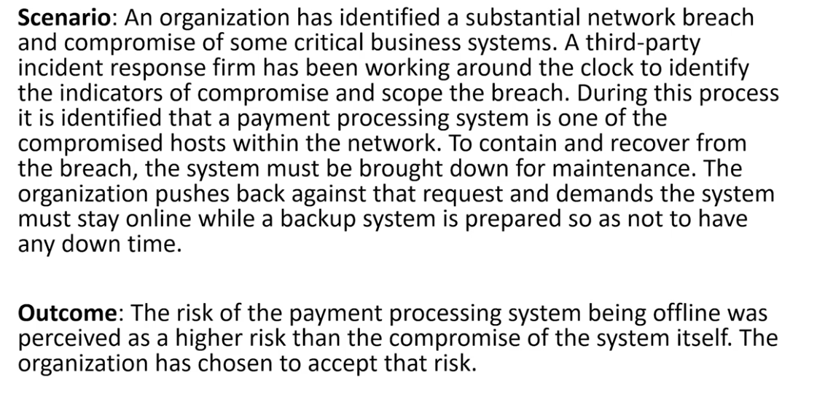

Risk Mitigation

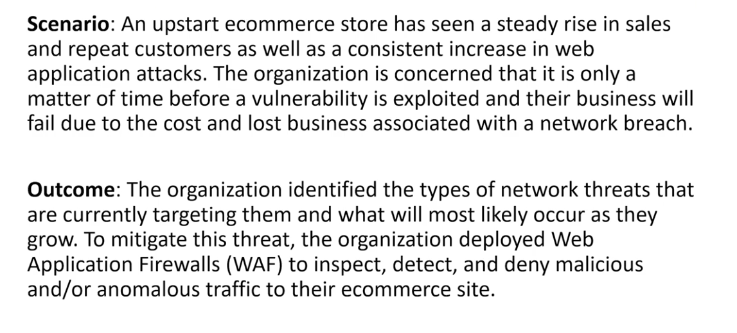

# GOVERNANCE

Organization stays inline with the business objectives.

## Governance Strategy

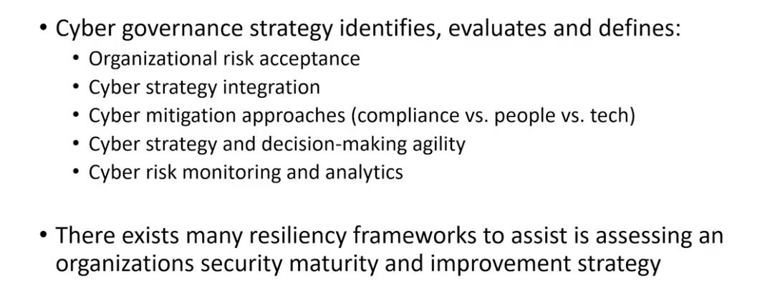

Cyber mitigation more refers to budget allocation. Cyver strategy refers to bureaucratic structure.

# NIST

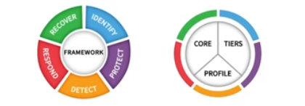

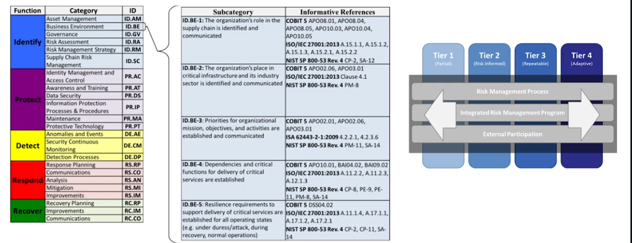

### NIST 800-53

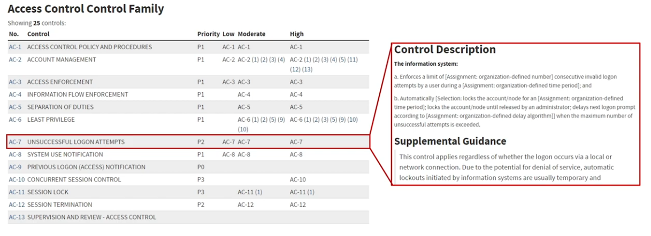NIST 800-30

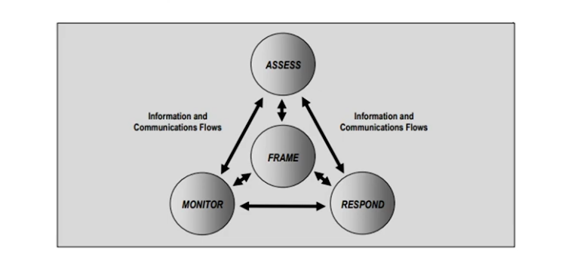

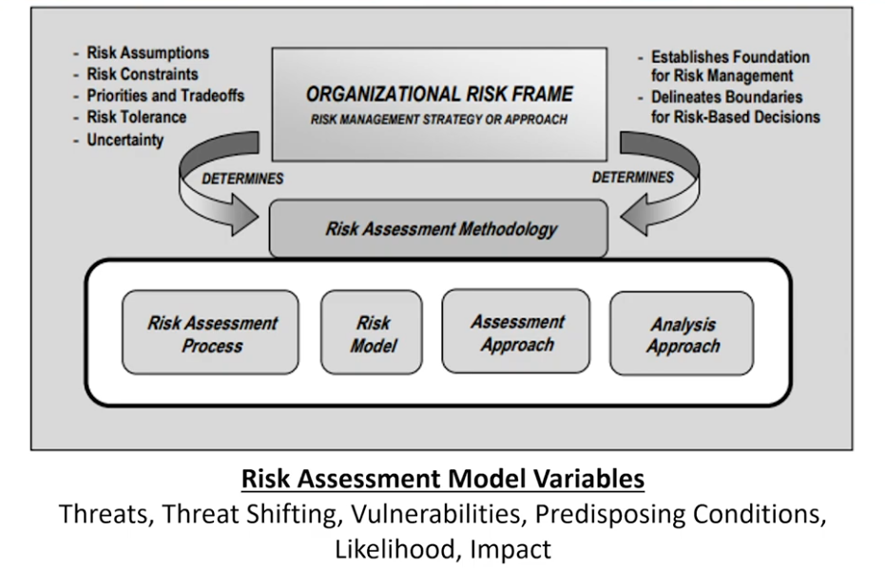

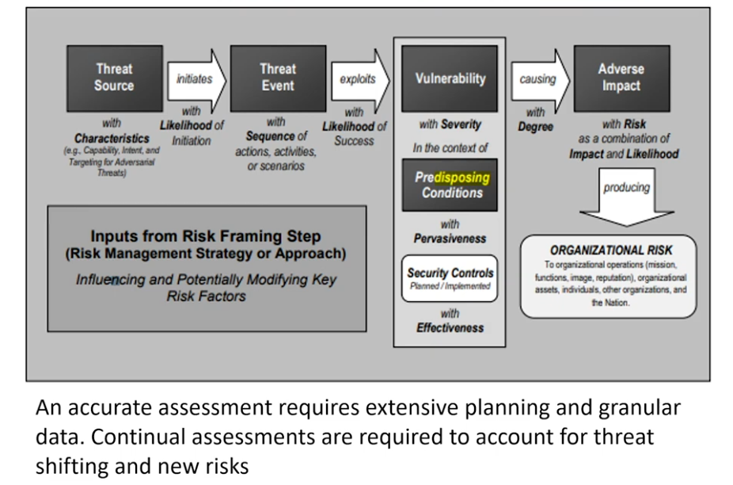

# COMPLIANCE

* Compliance is the process and adherence to legal, policy, industry standards and requirements.
* Noncompliance can lead to criminal, financial, license, business operations forfeiture
* Compliance requires monitoring, internal auditing, and external auditing or 'audit'.
* Internal audit is an organization assessment to evaluate compliance with a required legal, industry or policy requirement
* An external audit is conducted by a third party that evaluates the organizational compliance to those requirements

Few Examples:

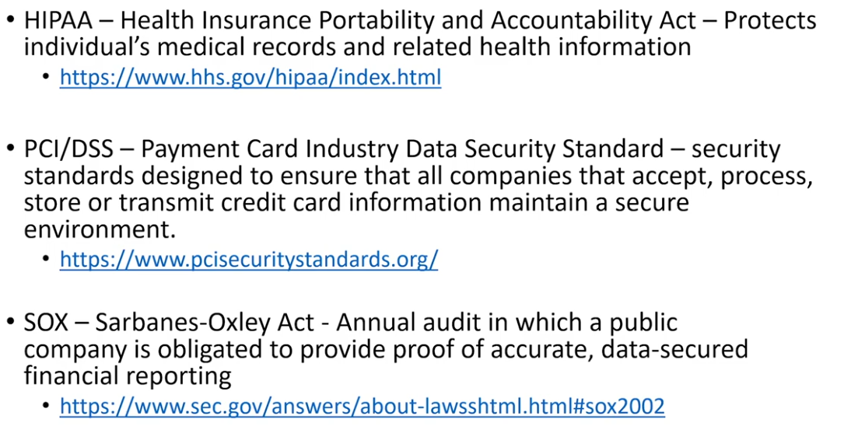

Some example of amazon using these frameworks

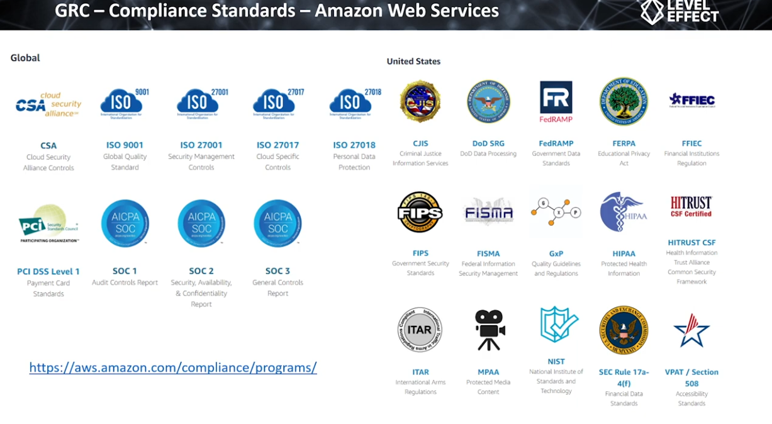

Being compliant does not means secure compliant means you just adhere to standards and control irrespective of their efficiency.

# ASSET MANAGEMENT

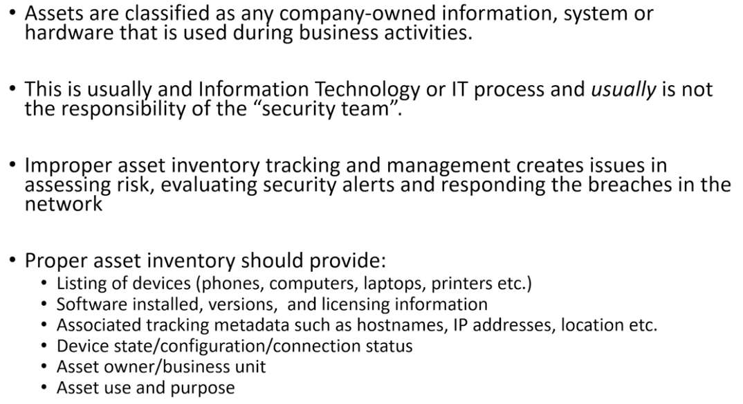

### Identifying networks

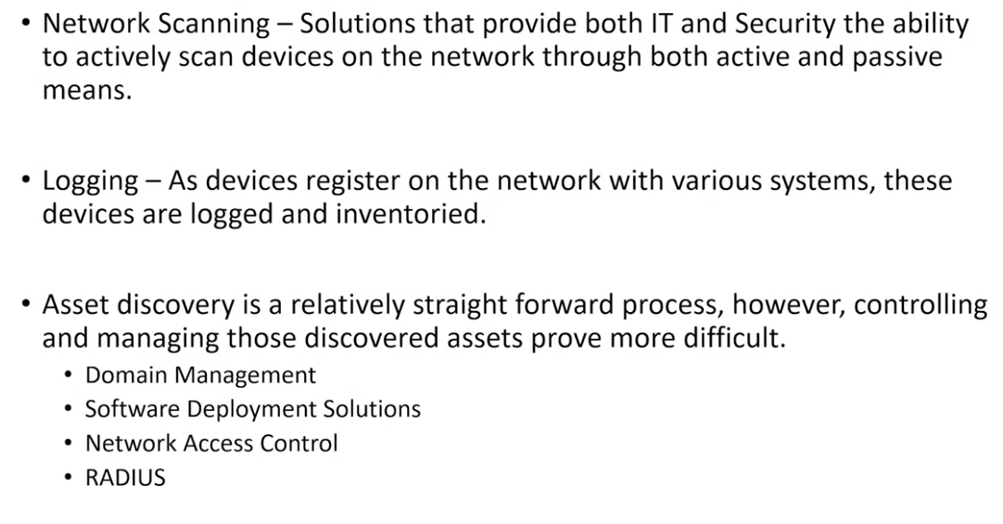

Logging examples: DNS, DHCP

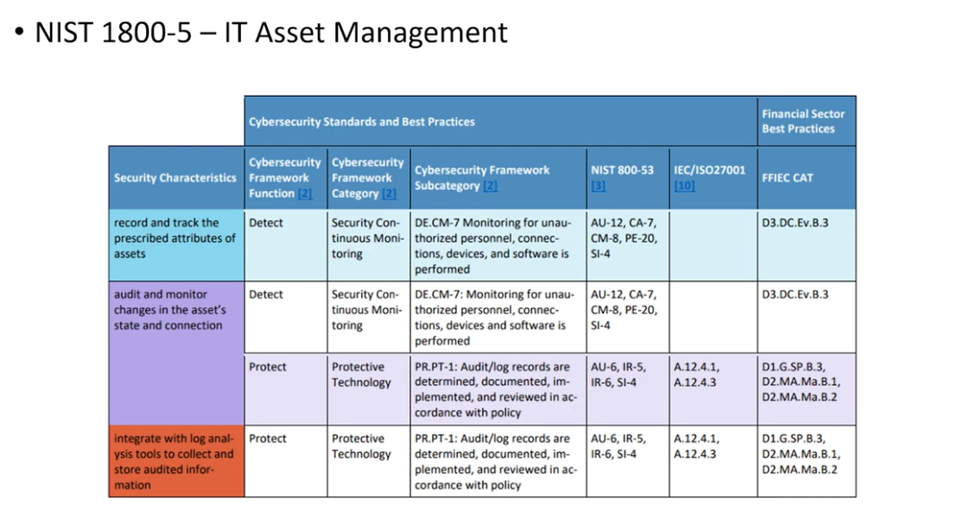

# CONFIGURATION MANAGEMENT

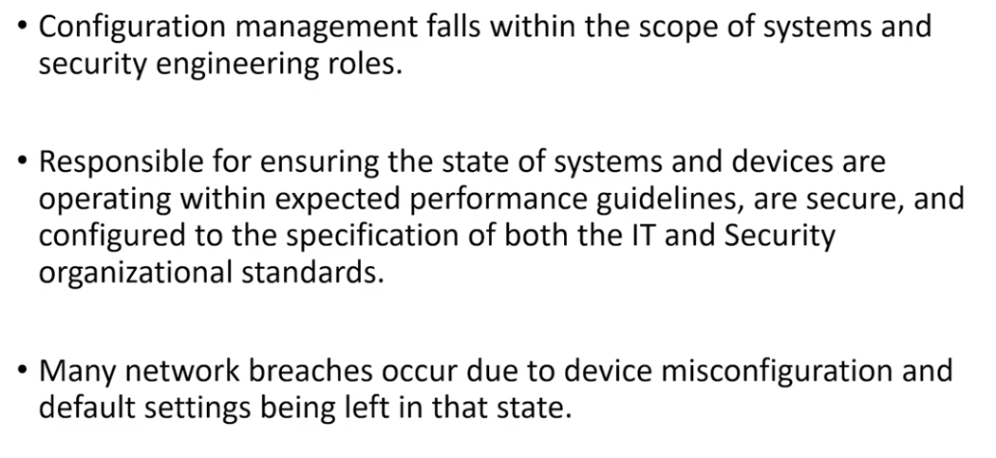

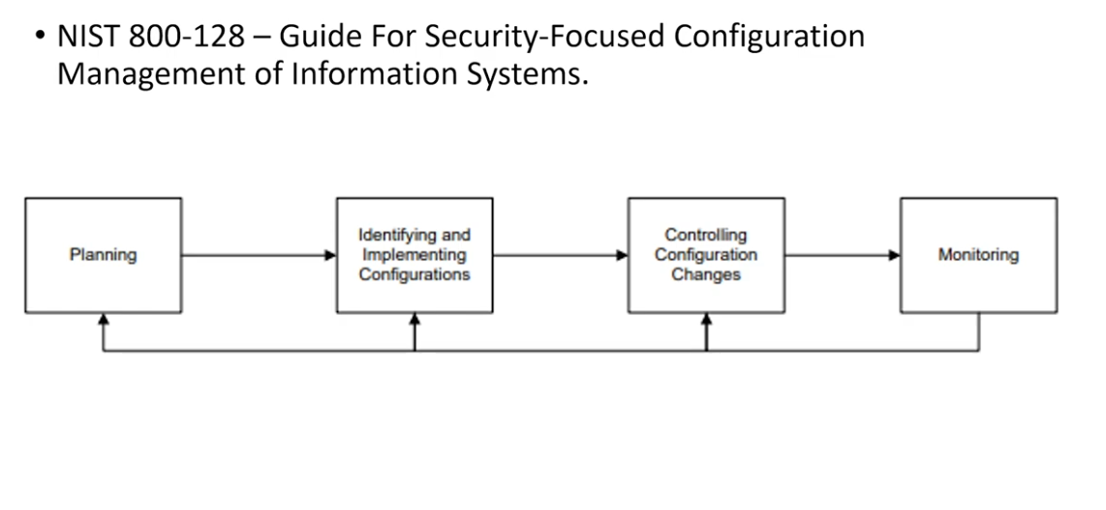

# PATCH MANAGEMENT

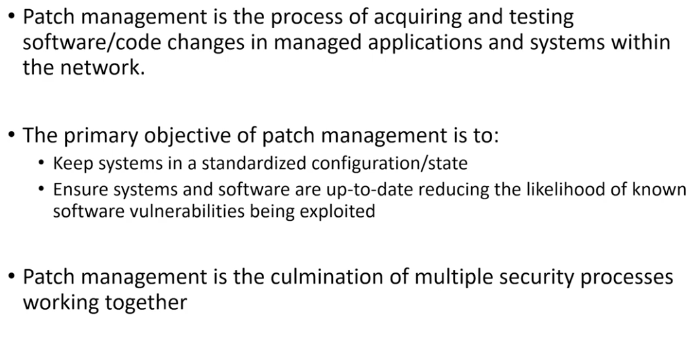

Patch is just updating a hardware/software that we are already using.

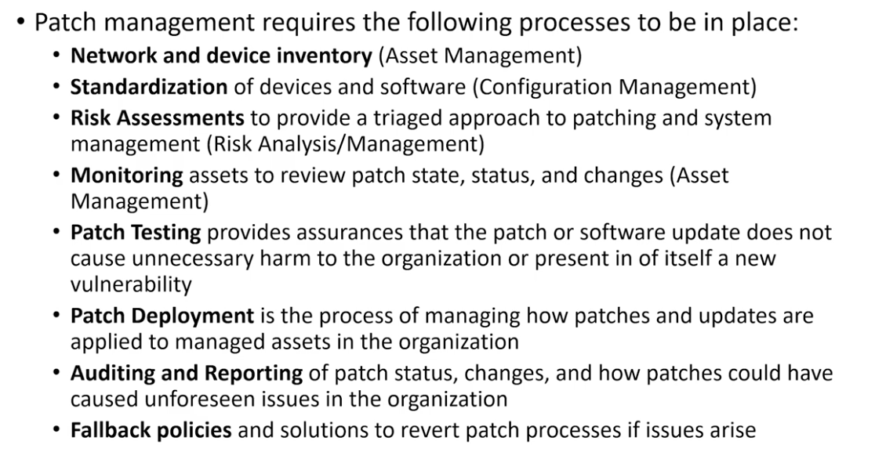

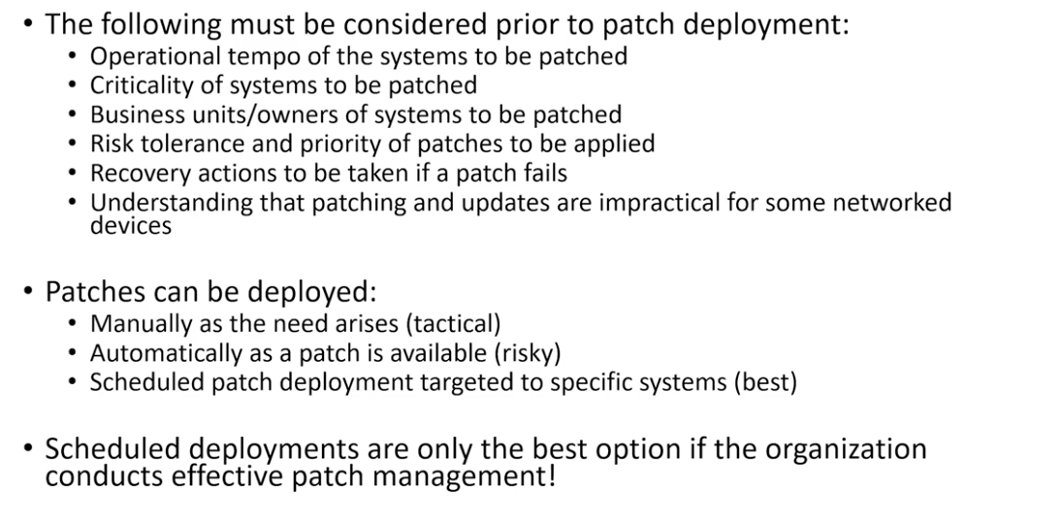

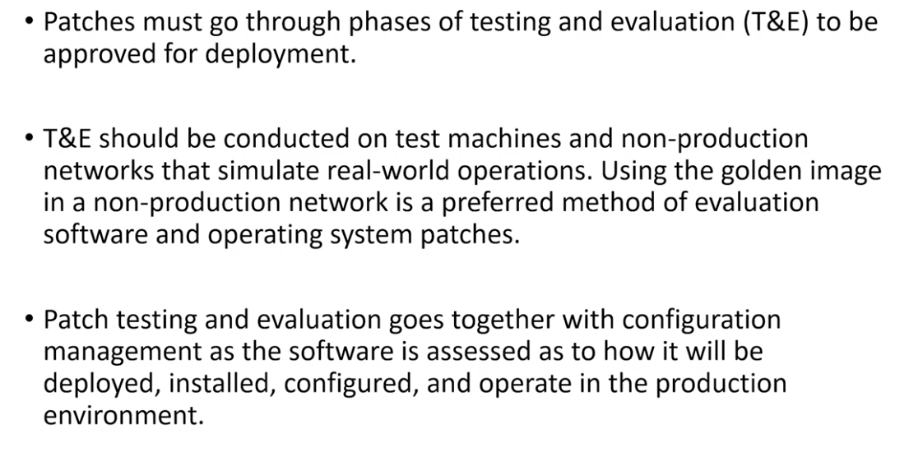

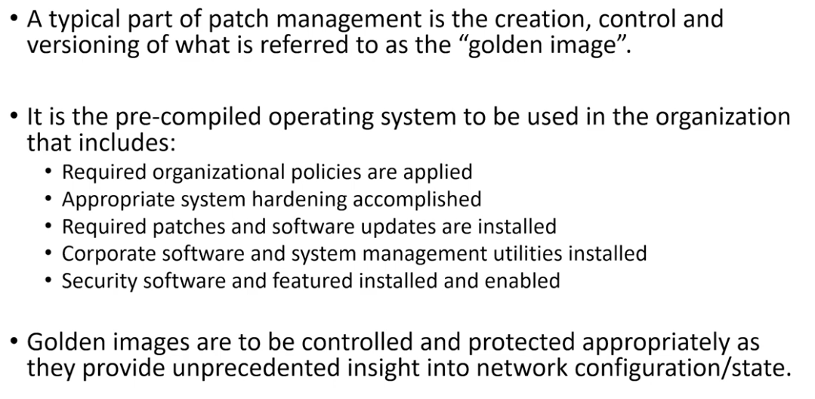

# VULNERABILITY MANAGEMENT

Which systems needs to be patched.

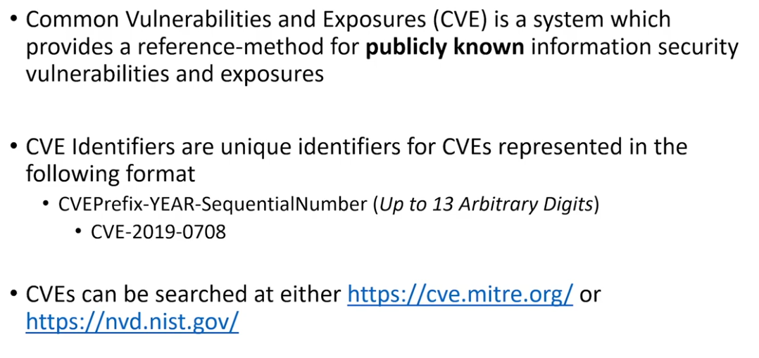

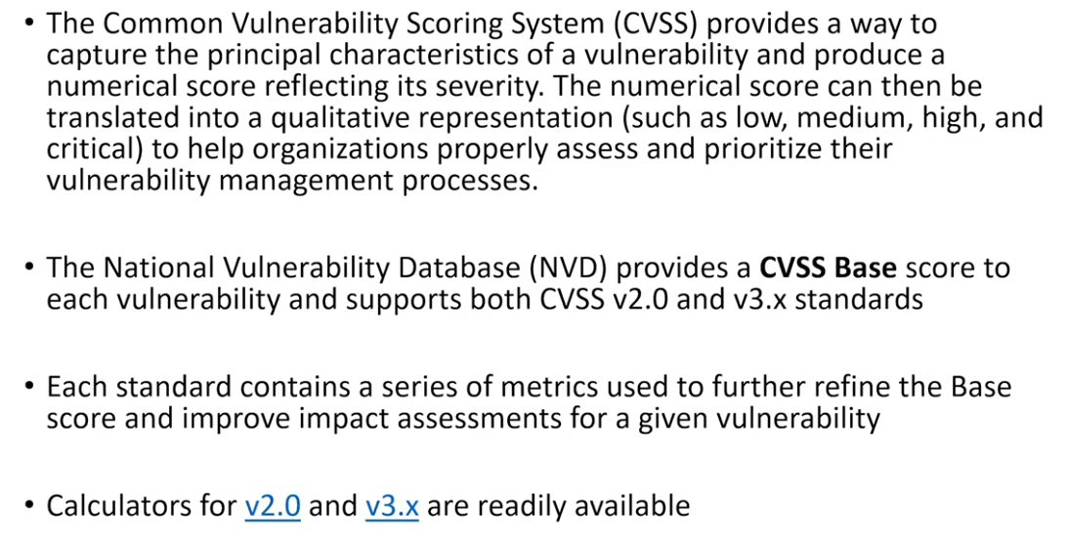

If the CVSS says that exploit is Remote Code Execution Vulnerability then its dangerous and can be exploited remotely.

# VULNERABILITY SCANNING

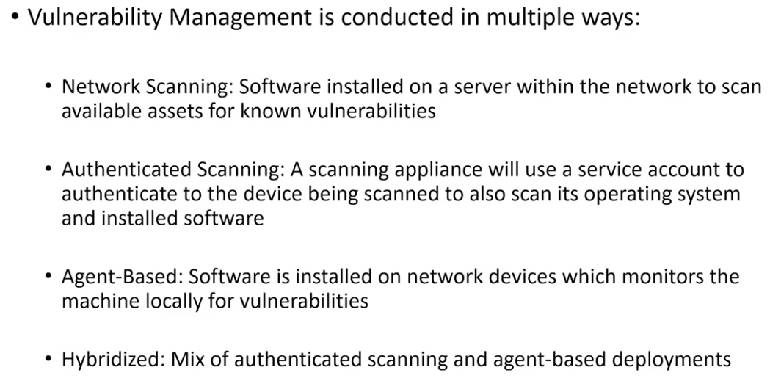

Vulnerability scanning is just a point in time analysis about a system state.

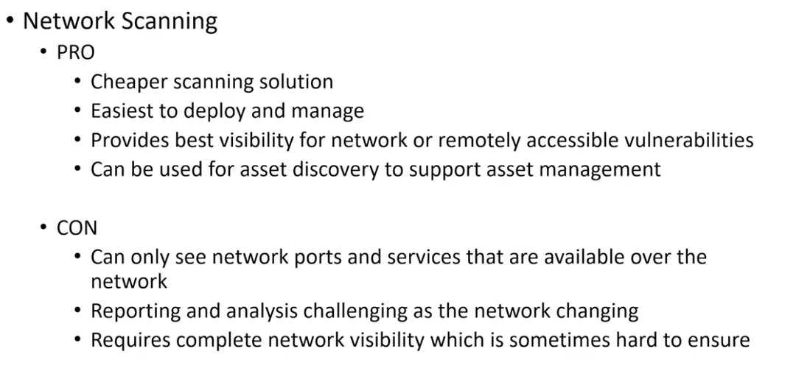

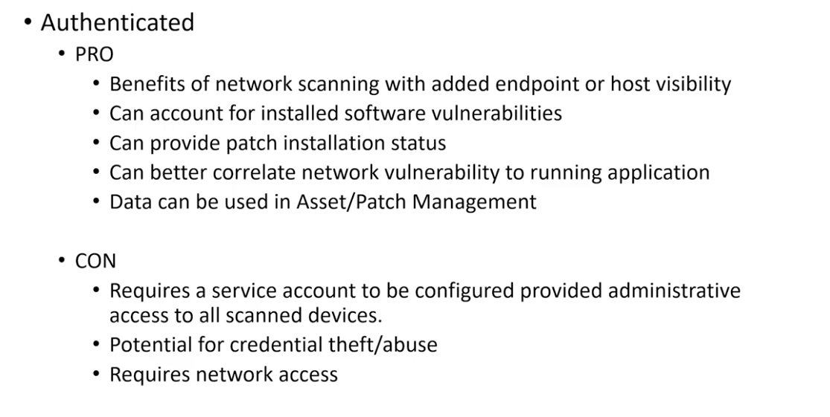

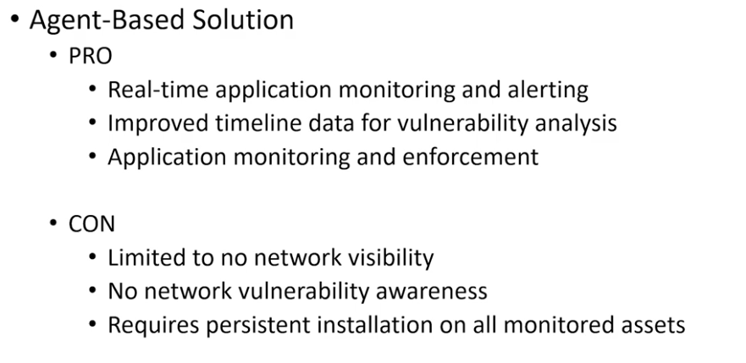

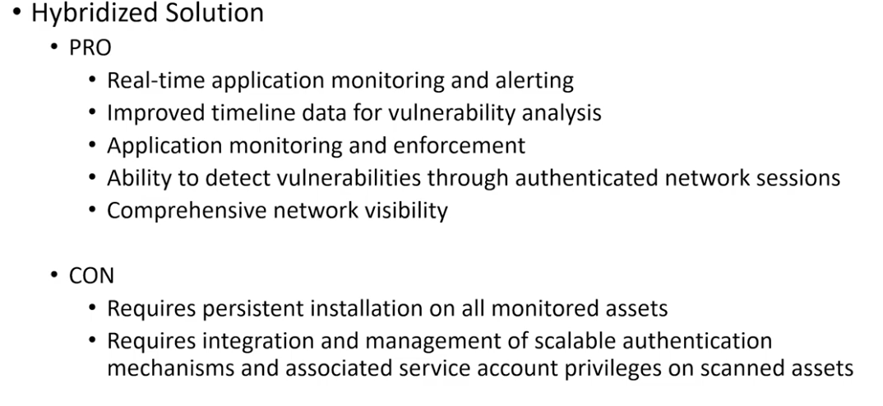

A new fresh vulnerability scanner deployement may cause other security tools to alarm and start logging because the hacker usually scans the network after getting access to it.

# VULNERABILITY TRIAGE

